MODEL PRACTICAL EXAM
NETWORKS LAB

Date : 11 November 2020
Name : S. Vishakan
Class : CSE – C
Reg. No. : 18 5001 196

Question:

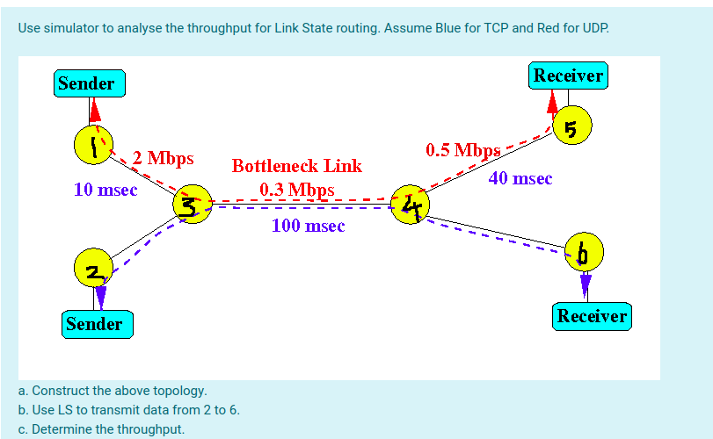
TCL Script File:

#Defining a new simulator object
set ns [new Simulator]

#Set Colors
$ns color 1 Blue
#TCP
$ns color 2 Red
#UDP

#Open the nam trace file
set f [open outLS.tr w]
$ns trace-all $f
set nf [open out.nam w]
$ns namtrace-all $nf

#Defining a finish procedure to execute the NAM file
proc finish {} {
global ns f nf
$ns flush-trace
close $f
close $nf
puts "Executing the NAM..."
exec nam out.nam &
puts "Throughputs & Packet Information for different packets\n"
exec awk -f LS_Proto.awk outLS.tr &
exec awk -f LS_TCP.awk outLS.tr &
exec awk -f LS_CBR.awk outLS.tr &
exit 0
}

#Constructing the topology
set n(1) [$ns node]
set n(2) [$ns node]
set n(3) [$ns node]
set n(4) [$ns node]
set n(5) [$ns node]
set n(6) [$ns node]

$ns duplex-link $n(1) $n(3) 2Mb 10ms DropTail
$ns duplex-link $n(2) $n(3) 2Mb 10ms DropTail
$ns duplex-link $n(3) $n(4) 0.3Mb 100ms DropTail
$ns duplex-link $n(4) $n(5) 0.5Mb 40ms DropTail
$ns duplex-link $n(4) $n(6) 0.5Mb 40ms DropTail

$ns duplex-link-op $n(1) $n(3) orient right-down
$ns duplex-link-op $n(2) $n(3) orient right-up
$ns duplex-link-op $n(3) $n(4) orient right
$ns duplex-link-op $n(4) $n(5) orient right-up
$ns duplex-link-op $n(4) $n(6) orient right-down

#Monitor the queue for the link n3-n4
$ns queue-limit $n(3) $n(4) 10
$ns duplex-link-op $n(3) $n(4) queuePos 0.5

#Creating TCP agent between n2 to n6
#Implementing a Newreno congestion control based TCP
#Implementing a DelAck TCPSink that delays acknowledgements

set tcp [new Agent/TCP/Newreno]
$tcp set class_ 1
$ns attach-agent $n(2) $tcp
set sink [new Agent/TCPSink/DelAck]
$ns attach-agent $n(6) $sink
$ns connect $tcp $sink

#upper limit on advertised window size for TCP connection
$tcp set window_ 8000

#TCP packet size in bytes
$tcp set packetSize_ 512

# Create a FTP application over TCP
set ftp [new Application/FTP]
$ftp attach-agent $tcp
$ftp set type_ FTP

#Creating UDP agent between n1 to n5
set udp0 [new Agent/UDP]
$udp0 set class_ 2
$ns attach-agent $n(1) $udp0
set null0 [new Agent/Null]
$ns attach-agent $n(5) $null0
$ns connect $udp0 $null0

# Create a CBR traffic source and attach it to udp0
#Constant Bit Rate traffic with packet size 1024 bytes, no random size packets, at 0.1Mb rate
set cbr [new Application/Traffic/CBR]
$cbr set type_ CBR
$cbr set packet_size_ 1024
$cbr set rate_ 0.1mb
$cbr set random_ false
$cbr attach-agent $udp0

#Stimulating LS routing protocol
$ns rtproto LS

#The n3-n4 link goes down at 4.0 sec, effectively
#stopping the transmission of packets
$ns rtmodel-at 4.0 down $n(3) $n(4)

#Schedule events for the CBR agent
$ns at 0.0 "$cbr start"
$ns at 1.0 "$ftp start"
$ns at 5.0 "$cbr stop"
$ns at 6.0 "$ftp stop"

#Call the finish procedure after 5 seconds simulation time
$ns at 6.0 "finish"

#Run the simulation
$ns run
Output:

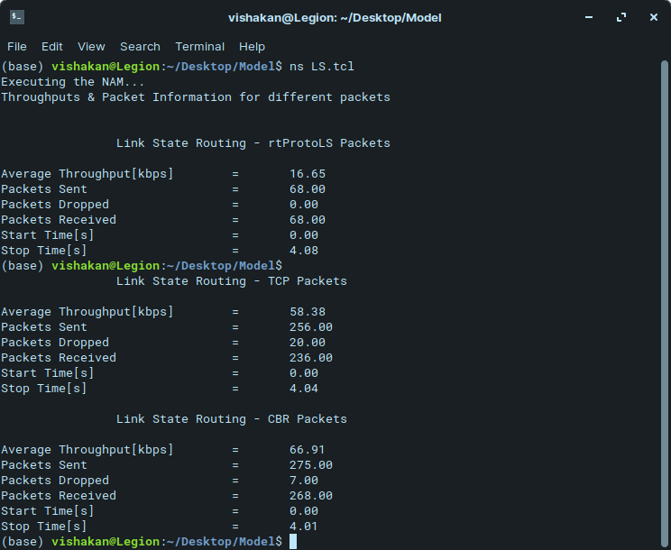

The Topology Layout with N0-N4 UDP and N1-N5 TCP Connection

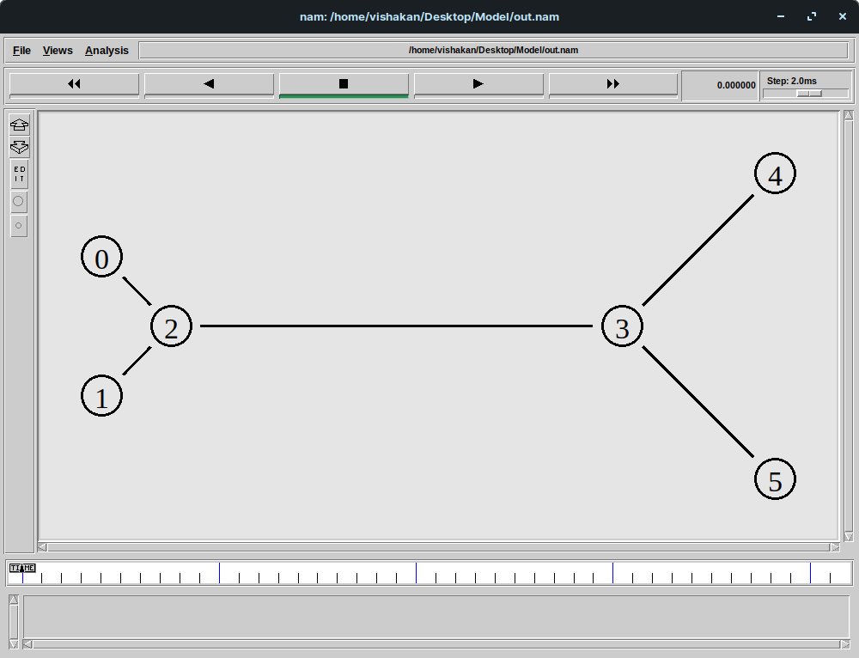

The Link State Packets Being Sent & Received
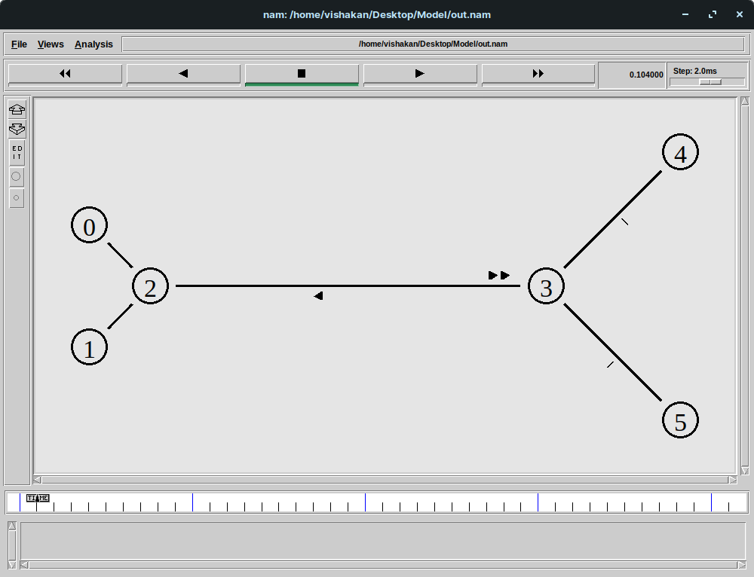

Packets being transmitted

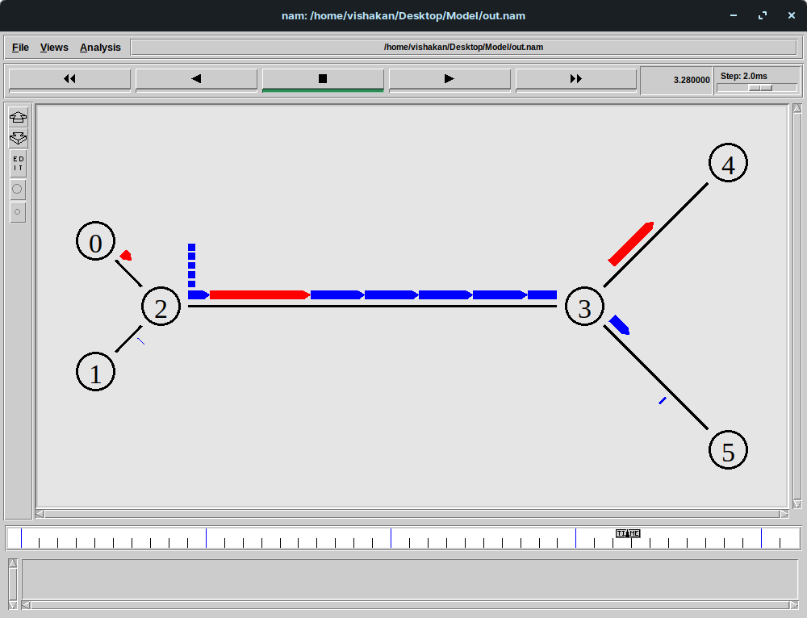
Packets being dropped at the node N2 due to bottleneck link N2-N3

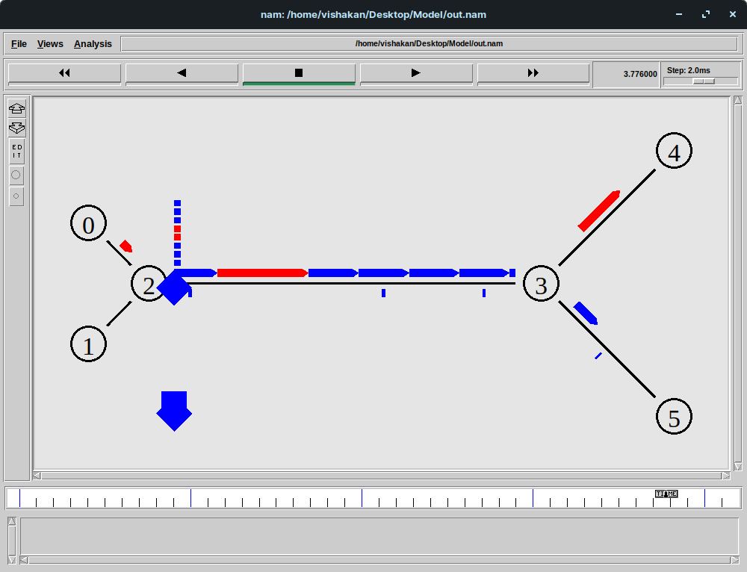

The bottleneck link fails at 4.0s and all packets are dropped
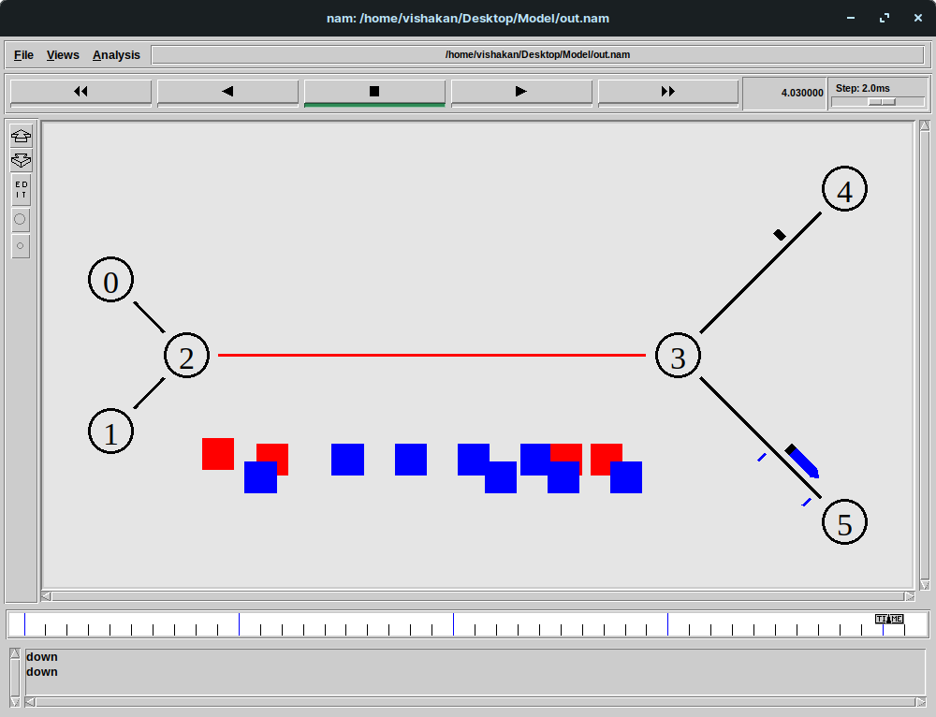
The transmission stops, after link state packets are sent and updated at the nodes, since there’s no pathway to transmit data, as the common link broke
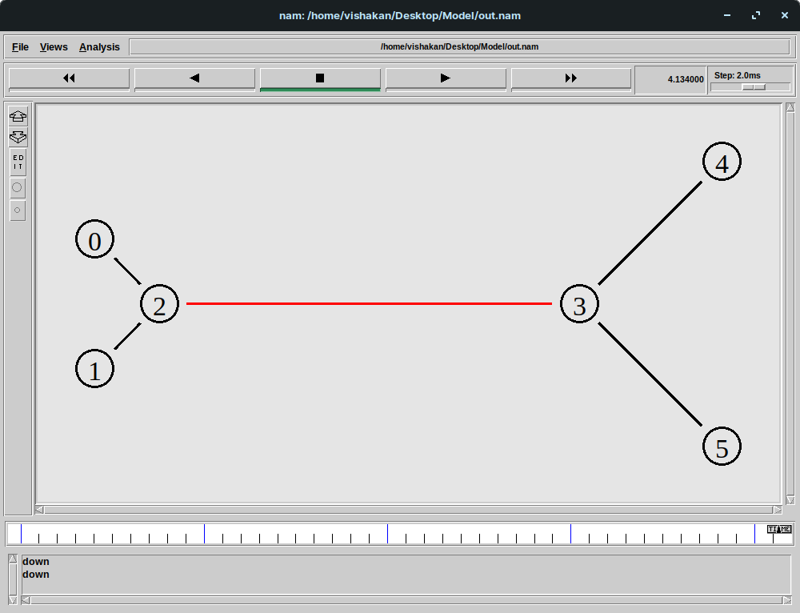
Result:

The given topology was constructed with a bottleneck link and the different parameters like throughput, the number of packets sent, the number of packets received and the number of packets dropped were calculated from the NS2 trace file using an AWK script.

